CS 340 Final Project README

About the Project
This project was developed for Grazioso Salvare, an international search-and-rescue
organization that trains dogs to find and rescue people in distress. Grazioso Salvare
recruits potential rescue dogs from animal shelters, but needs a fast, reliable way to
identify shelter animals that meet the physical and behavioral profile for specific
types of rescue work.

The project has two parts:
- The Animal Shelter CRUD Python Module (CRUD_Python_Module.py) — a reusable Python
class that provides Create, Read, Update, and Delete (CRUD) operations against a
MongoDB database holding the Austin Animal Center (AAC) outcomes dataset.
- The Grazioso Salvare Interactive Dashboard (ProjectTwoDashboard.ipynb) — a
browser-based dashboard, built with Plotly Dash and running inside a Jupyter
Notebook, that sits on top of the CRUD module and lets Grazioso Salvare staff search,
filter, and visualize shelter animal data without writing any code or queries
themselves.

Required Functionality

The dashboard was required to:
- Connect to the MongoDB AAC database through the CRUD module (no
direct/raw queries written in the dashboard code).
- Display the unfiltered animal data set in an interactive, sortable, paginated data
table.
- Provide filtering options corresponding to the three rescue-animal profiles Grazioso
Salvare uses, plus a "Reset/All" option:
  - Water Rescue — Labrador Retriever Mix, Chesapeake Bay Retriever, Newfoundland;
Intact Female; age 26–156 weeks.
  - Mountain or Wilderness Rescue — German Shepherd, Alaskan Malamute, Old English
Sheepdog, Siberian Husky, Rottweiler; Intact Male; age 26–156 weeks.
  - Disaster or Individual Tracking — Doberman Pinscher, German Shepherd, Golden
Retriever, Bloodhound, Rottweiler; Intact Male; age 20–300 weeks.
- Update a pie chart in real time to reflect the breed distribution of whatever subset
of data is currently displayed in the table.
- Plot the geolocation of the animal currently selected in the data table on an
interactive map, with a popup showing identifying information (name and breed).
- Display the developer's identifying information/customized logo (per course
requirements) somewhere on the dashboard layout.

Resources and Software Used
MongoDB — database server
MongoDB Compass — GUI used to inspect
the AAC database and animals collection during development
PyMongo Documentation — Python driver for MongoDB
Dash by Plotly Documentation — web application framework
JupyterDash on PyPI — Dash-in-Jupyter support
Dash Leaflet — interactive mapping component
Plotly Express Documentation — charting
Jupyter Notebook — development/testing environment
Austin Animal Center Outcomes Dataset — source data
imported into MongoDB

Getting Started

Database Setup
Install MongoDB.
Import the AAC animal shelter dataset into MongoDB.
Create the AAC database and animals collection.
Create a database user with appropriate permissions.

Python Module Setup
Install Python 3.
Install the required libraries: pymongo.
Create the AnimalShelter.py file.
Add the MongoDB connection code.
Implement the Create, Read, Update, and Delete methods.

Dashboard Setup
Install the additional required libraries: dash, jupyter-dash, dash-leaflet,
pandas, plotly.
Open ProjectTwoDashboard.ipynb in Jupyter Notebook.
Update the MongoDB connection parameters (host, port, username, password) to match
your local environment.
Run all cells. The dashboard will launch inline in the notebook or in a browser tab,
depending on the run mode selected.

Installation
MongoDB
Python 3
Jupyter Notebook
PyMongo
Dash / JupyterDash
Dash Leaflet
Pandas
Plotly

Usage
The Animal Shelter Module can be imported into another Python application to preform database operations.

Code Example
Create Function
def create(self, data):
if data is not None:
self.database.animals.insert_one(data) # data should be dictionary
else:
raise Exception("Nothing to save, because data parameter is empty")

Read Function
def read(self, query):
if query is not None:
try:
data = self.database.animals.find(query)
return list(data)
except Exeception as e:
print("Read failed:", e)
return[]
else:
raise Exception("Nothing to read, because query is empty")
Update Function
def update(self, query, newData):
if query is not None and newData is not None:
try:
result = self.database.animals.update_many(
query,
{"$set": newData}
)
return result.modified_count
except Exception as e:
print("Update failed:", e)
return 0
else:
raise Exception("Nothing to update, because query or newData is empty")
Delete Function
def delete(self, query):
if query is not None:
try:
result = self.database.animals.delete_many(query)
return result.deleted_count
except Exception as e:
print("Delete failed:", e)
return 0
else:
raise Exception("Nothing to delete, because query is empty")

Tests
Test for Create
new_animal ={
"animal_id": "TEST001",
"animal_type": "Cat",
"breed": "Bengal",
"name": "Jojo"
}
result = shelter.create(new_animal)
print("Insert Successful:", result)

Test for Read
query = {"animal_id": "TEST001"}
results = shelter.read(query)
for animal in results:
print(animal)

Test for Update
update_result = shelter.update(
{"animal_id": "TEST001"},
{"name": "Lily"}
)
print("Documents Updated:", update_result)
Test for Delete
delete_result = shelter.delete(
{"animal_id": "TEST001"}
)
print("Documents Deleted:", delete_result)
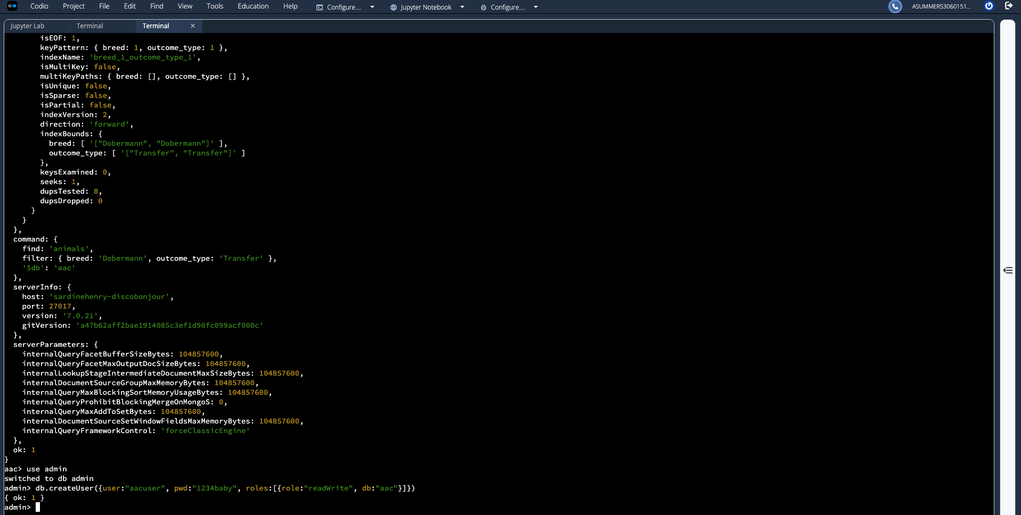

Screenshots

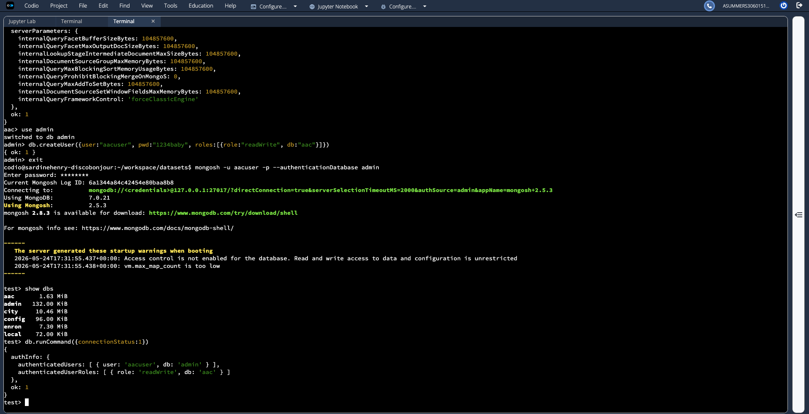

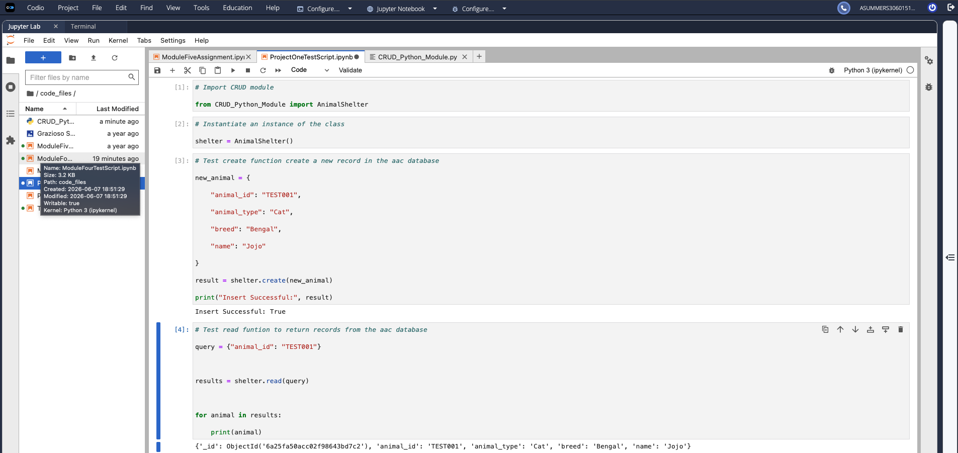

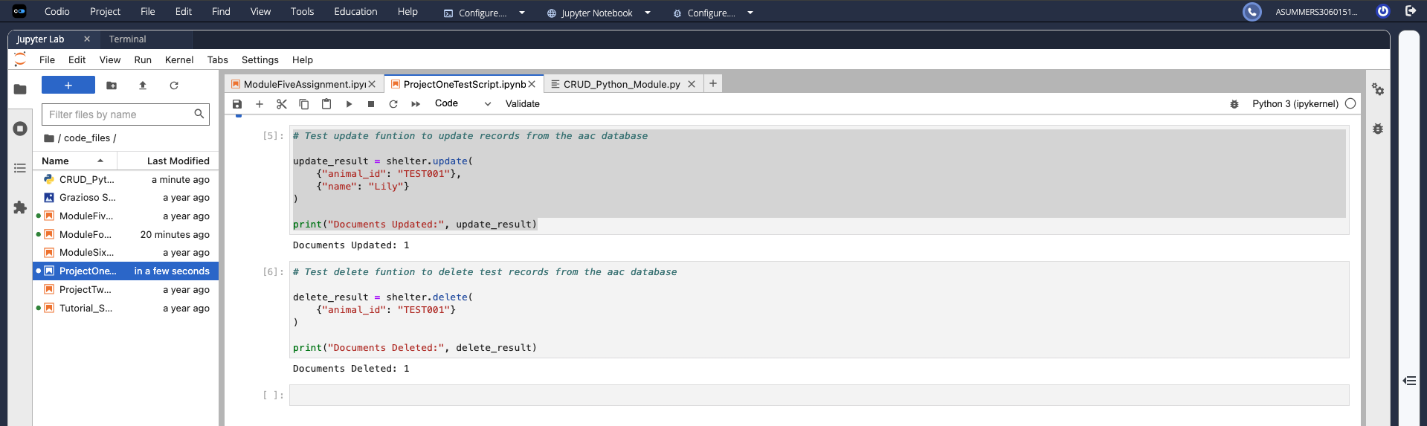

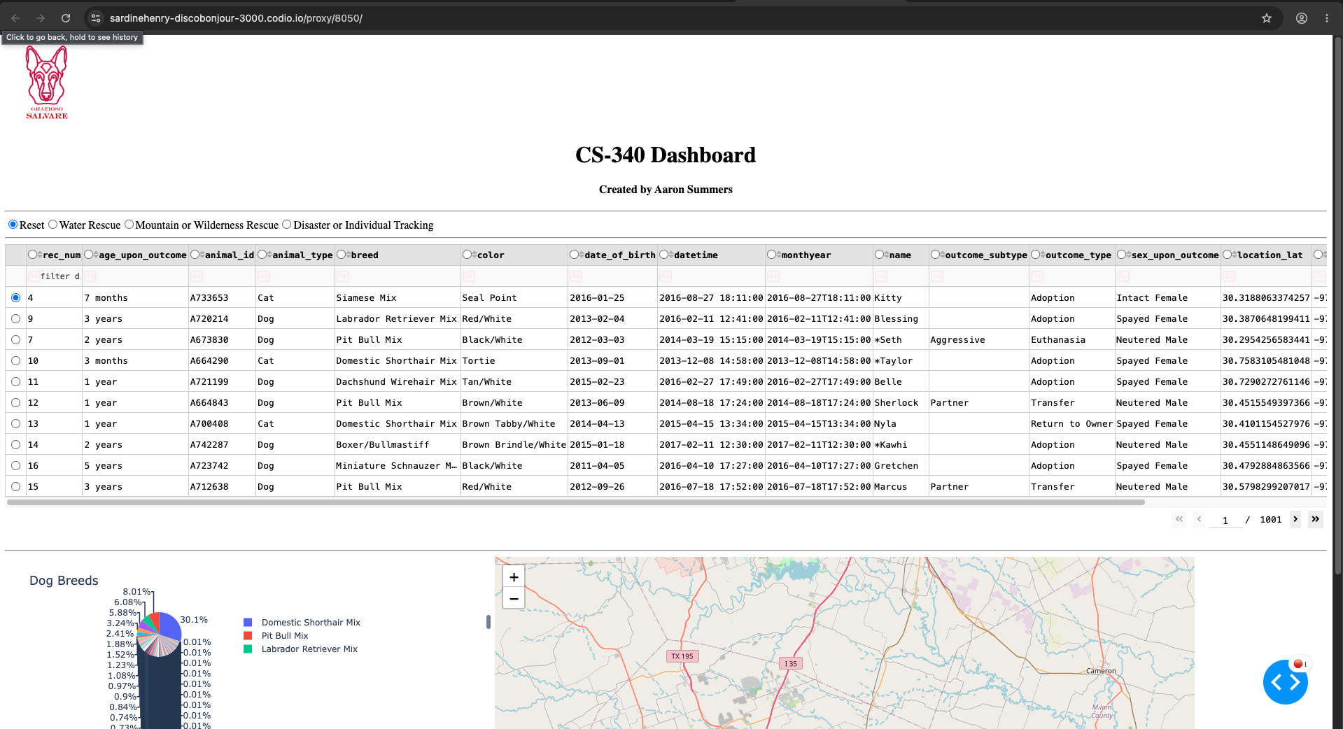

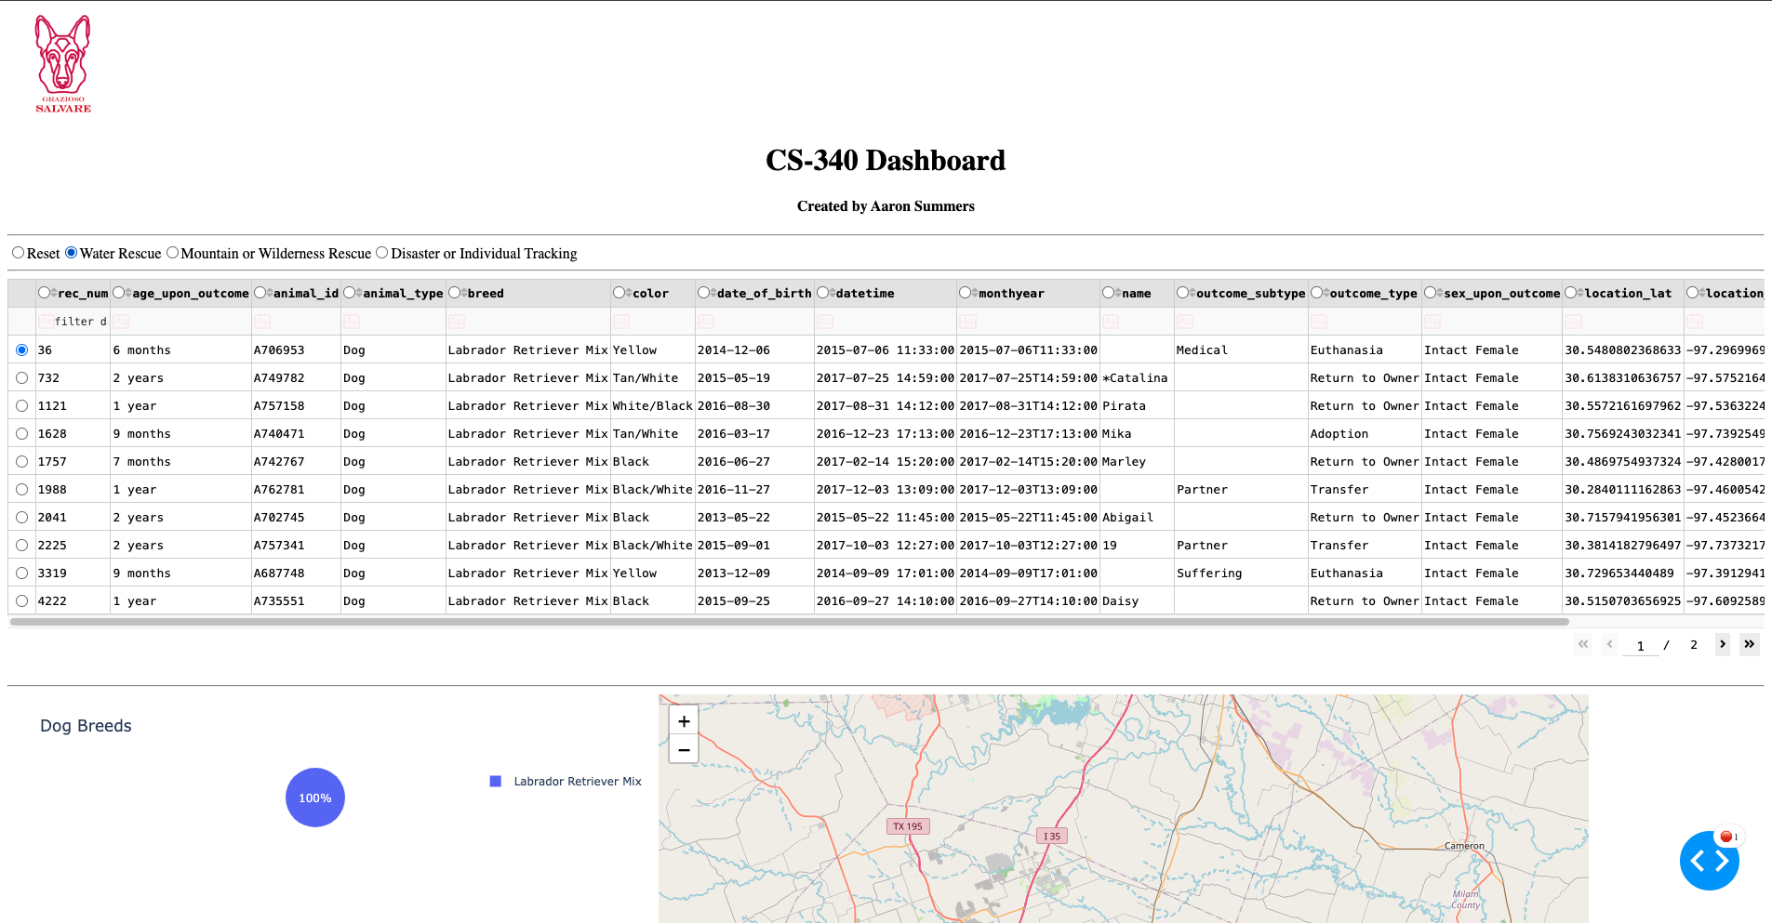

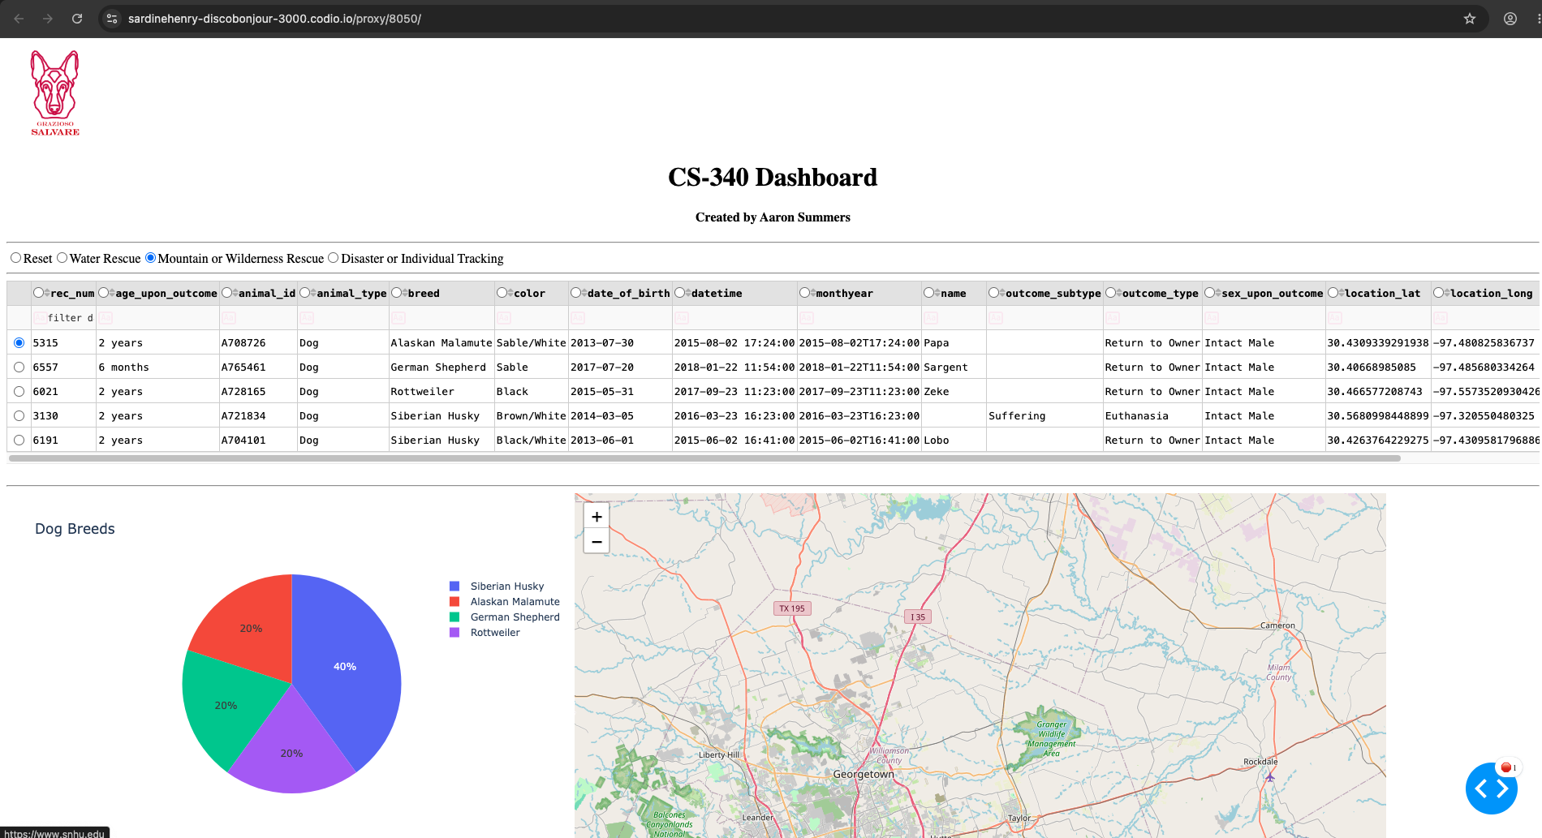

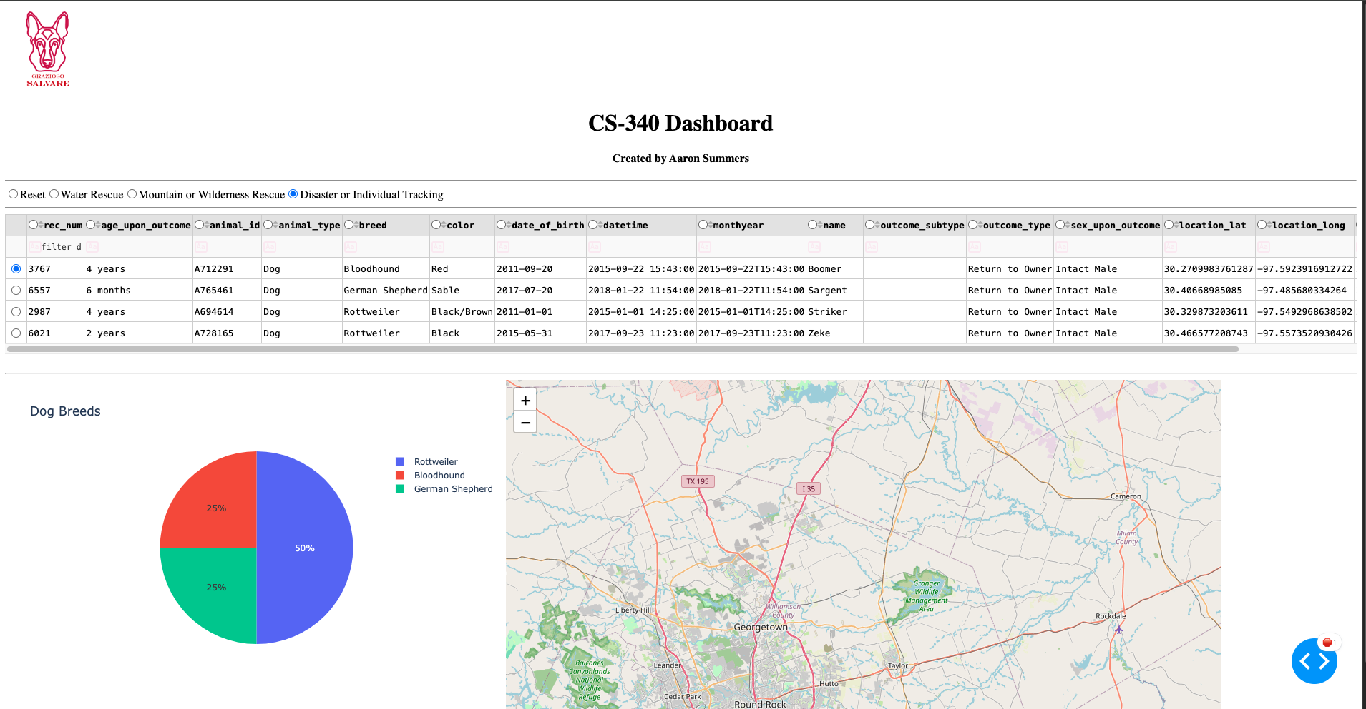

Contact
Your name: Aaron Summers

